Component Architecture Method
Possible Solutions to Exercises



Describe Objects

Interacting Objects
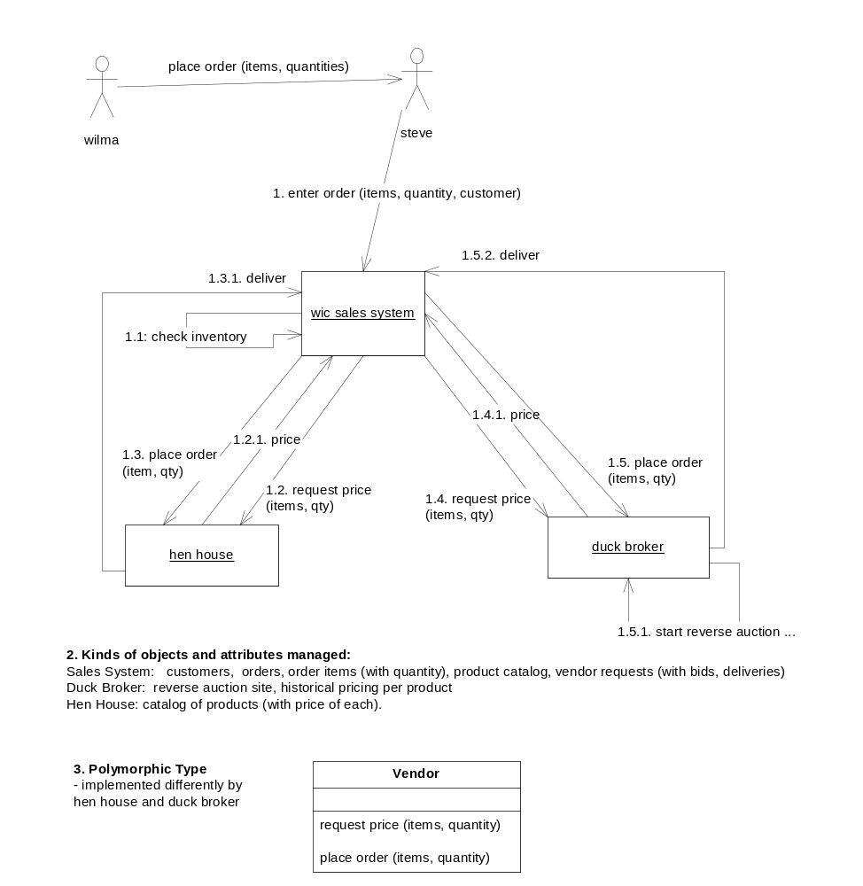

b) Find Multiple Types
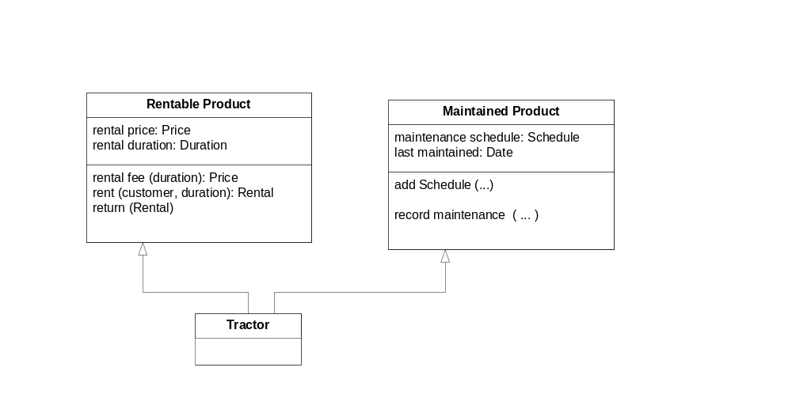
If an object with 2 types is represented in 2 different software systems as 2 disconnected objects, keeping them in synch needs to be addressed/dealt with.

3.1 Objects, Snapshots
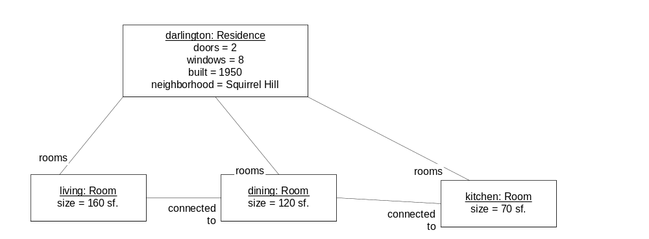

3.2 Information Model

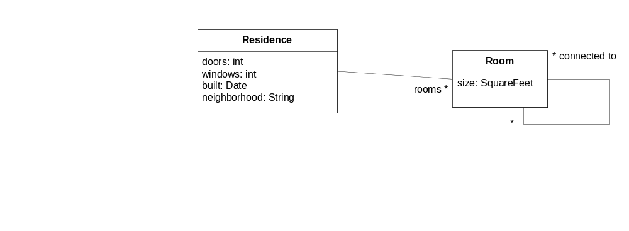

3.3 Snapshot Pairs
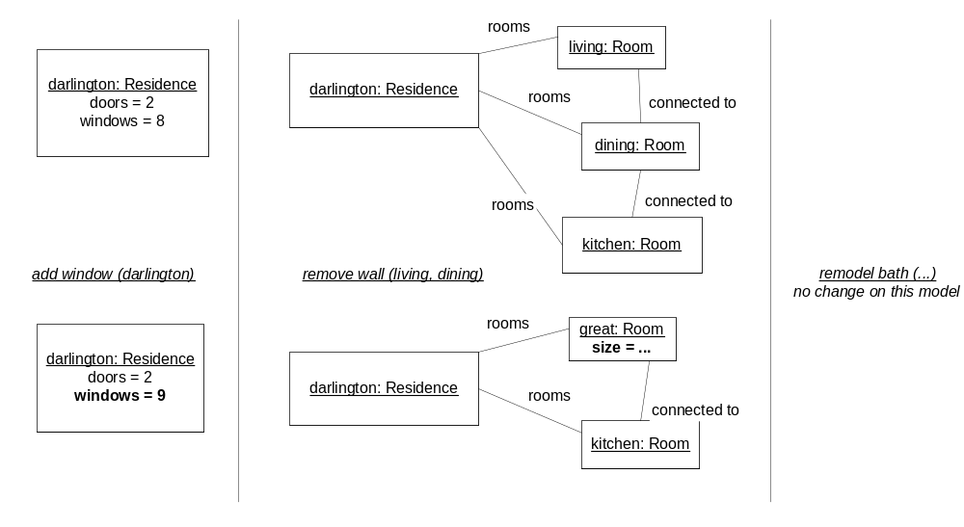

3.4 Actions

action add Window ( r : Residence)
description: the house is remodeled to add a new window to a residence
precondition: none
postcondition: the number of windows in the residence r is one greater than before

action remove Wall ( r1: Room, r2: Room)
description: the house is remodeled to join two contiguous rooms into one
precondition: the two rooms are connected to each other
postcondition: the rooms r1, r2 are gone. A new room, r3, is created and added to house rooms.
r3 is connected to all the rooms that r1 and r2 were connected to.
the size of r3 is the sum of the sizes of r1 and r2.

3.5 Scenarios with text and snapshots
Scenario name: new wing on mansion
Initial state: Titus is a contractor, Jake the homeowner
- titus and jake sign the contract
- titus lays the foundation
- titus raises the walls
- titus adds the roof
- titus and jake do the walkthrough
- jake adds the windows
- jake adds the doors
- jake adds the finished flooring
Final state: the new wing is complete

Snapshots: this would probably require new types of objects for Wing, Foundation, Roof, Wall.

3.6 Activity Diagrams
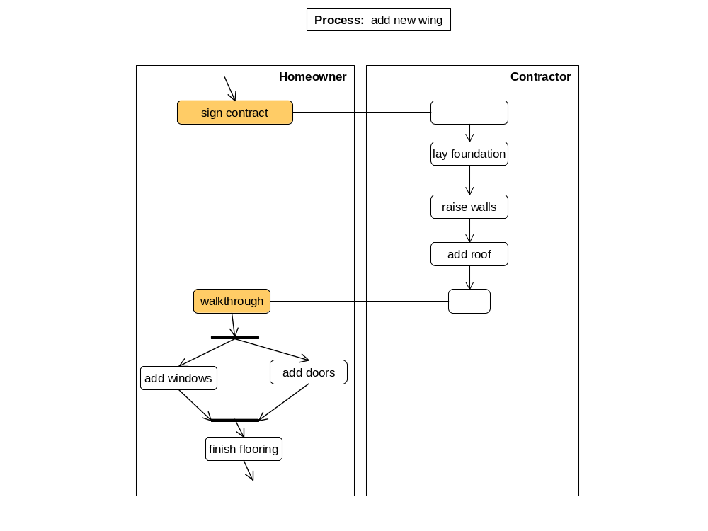

4.1 Draw Object Snapshots, Build Information Model from Snapshots. Understand Navigation Expressions.

Snapshots & User Interface

Note: information not shown in snapshot is simply omitted, rather than lost.
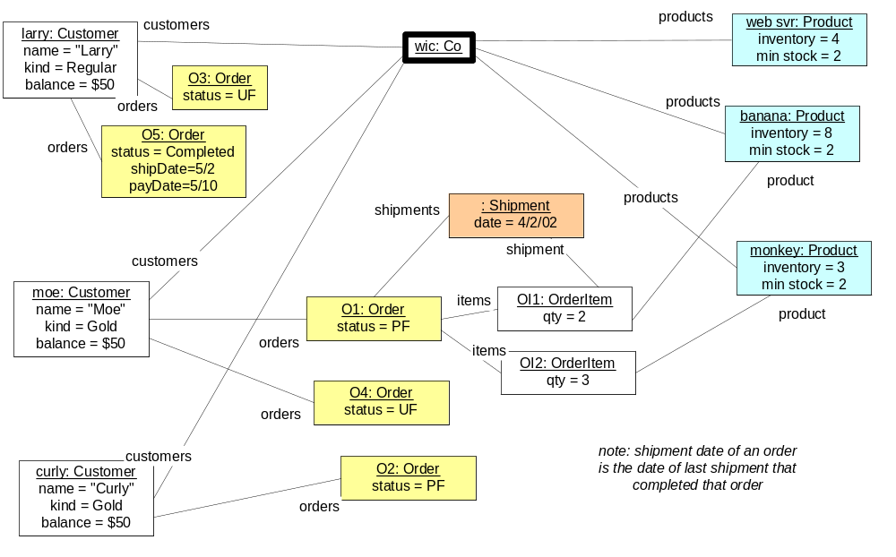

Creation:
  - Customer: when the company gets a new customer
  - Order: when a customer places an order
  - Order Item: when a new item is added to an order (as part of when a customer places an order)
  - Product: when a new product is added to the catalog
  - Shipment: when a shipment is made for some order items in the order

Build Information Model from Snapshots

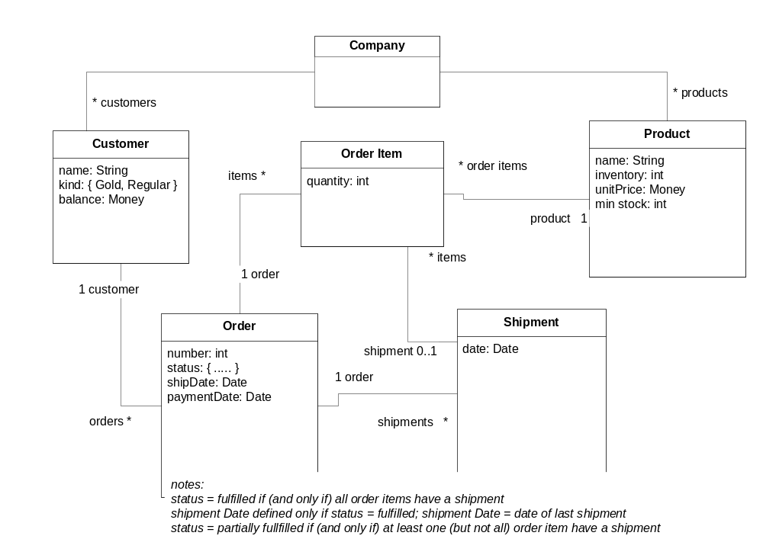

(c) Interpret Navigation Expressions
- wic.customers = { larry, moe, curly }
- wic.customer → select( cust | cust . name = “larry”) = larry
- larry.orders = [any other way to refer to larry].orders = { o3, o5 }
- larry.orders → select (ord | ord . status = Unfilled) = { o3 }
- all wic orders placed by gold customers = { o1, o2, o4 }
- all products which cost less than $25

(d) Write Navigation Expressions
- wic.customers.orders → select ( o | o.status = PartiallyFulfilled).customer
- wic.orders → select ( o | o.status = PartiallyFulfilled)

4.2 Convenience Attributes. Invariants. Supertypes.

a) Introduce convenience attributes
- all products with inventory
Company
inStockProducts : Set(Product)
- the current need for a product
Product
currentNeed : integer
- percentage of orders with 2 or less shipments
Company
totalCompletedOrders : integer
totalEfficientCompletedOrders: integer
efficientlyShippedOrders : Percentage

b) write invariants
- Company:: inStockProducts : Set(Product)
all products whose inventory is greater than 0
products→select (p | p.inventory > 0)
- Product:: currentNeed : integer
the sum of the ordered quantity for a given product’s orderItems that have not been shipped.
orderItems→select (item | not item.shipped) → sum( item | item.quantity)
(where item.shipped could be defined as, or replaced by, item.shipment <> null)
- Company:: totalCompletedOrders: integer
the count of the orders which have been completed.
customers . orders → count (o | o.completed)
Company:: totalEfficientCompletedOrders: integer
the count of the orders which have been completed with 2 or less shipments.
customers . orders → select (o | o.completed and o.shipments→ size <= 2)
(where o.completed could be defined as, or replaced by, o.shipDate <> null)
Company:: shippingEfficiency : Percentage
the ratio of totalEfficientCompletedOrders to totalCompletedOrders
100 * totalEfficientCompletedOrders / totalCompletedOrders
- for any order, there are never two or more orderItems which have the same product.

c) utilize supertypes
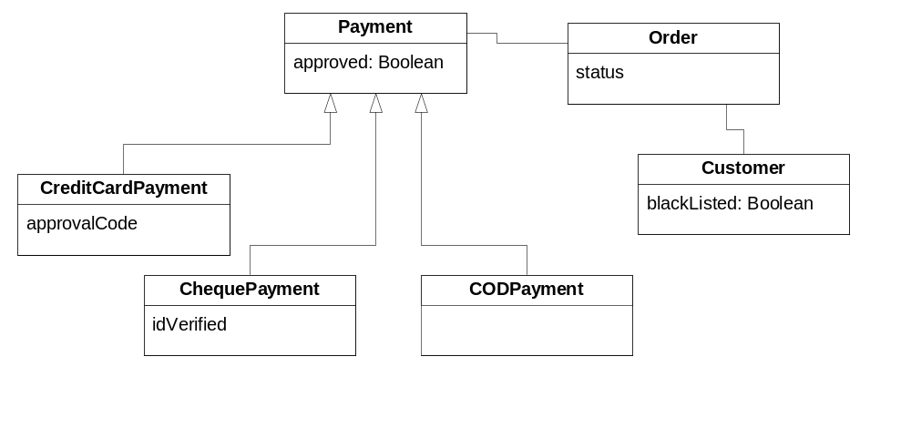
Invariant on Order: if payment is not approved then status is not fulfilled
there are different types of payments: by credit card, by cheque, by COD.
supertype is Payment
generic attribute – approved : boolean – is used to determine if an order can be fulfilled
subtypes and attributes needed
CreditCardPayment – approvalCode on this type
approved means approvalCode not null
ChequePayment - idVerified on this type
approved means idVerified = true
CODPayment – blacklisted on Customer type
approved means customer.blacklisted = false
(where customer may be defined as order.customer)

4.3 Define Scenarios and Snapshot Pairs.

(a) Scenarios and Snapshot Pairs
- the long-lived activity could be: buy products
starts – when moe places an order with WIC.
ends – when moe has received order in full and paid for it
- the finer grained actions could be: place order, make shipment, pay for order.
the type could be: Order.
the states could be: unfulfilled, partiallyFulfilled, completed, paid, cancelled.
- scenario: moe buys monkeys and bananas
initial state: moe is an existing customer of wic. wic has 3 monkeys and 10 bananas in stock.
scenario steps
1. moe calls wic and places an order for 3 monkeys and 2 bananas.
result - a new order exists for moe and has the items ordered.
2. charley, a wic employee, gets 2 bananas from stock and ships them to moe.
result - a new shipment associated with the bananas orderItem for moe’s order; inventory of bananas is reduced by 2.
3. moe receives the bananas.
4. sandra, a wic employee, gets 3 monkeys from stock and ships them to moe.
result - a new shipment associated with the monkeys orderItem; monkey inventory reduced; order completed. 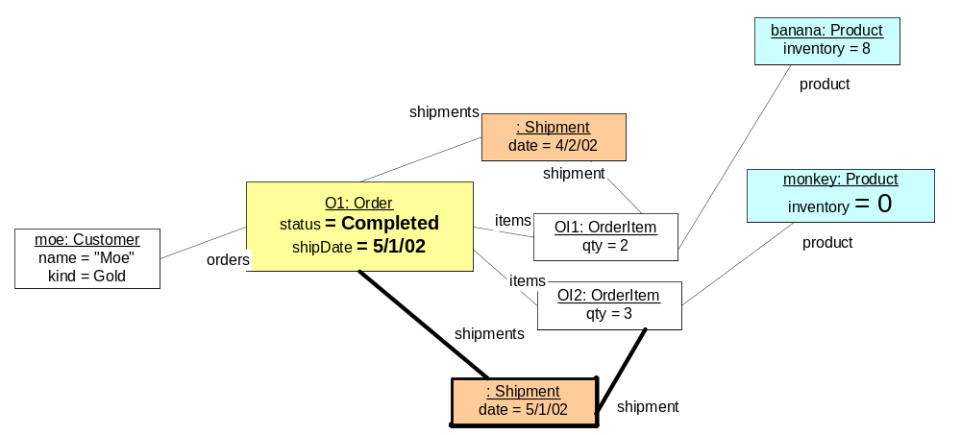
5. moe receives the monkeys.
6. moe sends payment to wic for his monkeys and bananas.
final state: wic has fewer bananas and monkeys, more money. Moe has bananas and monkeys. Moe’s order is completed and paid.
- after step 1 – o1, oi1, oi2 and links between them exist; link from moe to o1 exists.
after step 2 – sh1 and link to oi2 exists. banana.quantity goes to 6 from 8.
after step 4 – sh2 and link to oi1 exists. monkey.quantity goes to 0 from 3.
o1.shipdate and status updated.
- possible interference or exceptions
moe attempts to order items that are out of stock and cannot be obtained
the shipments get lost or sent to the wrong location (will require changes to model)
moe does not pay for the products he receives (might require time-based event and changes to model)

(b) Specify an Action
- informal description for post-conditions
makeShipment
postcondition: the order has a new shipment with today’s date and is associated with each shippable orderItem.
each shippable orderItem is shipped.
each shippable orderItem’s product’s inventory is reduced by the orderItem’s quantity.
if all orderItems are shipped, the order is completed and it’s shipDate is today. otherwise, it is partiallyFulfilled (this could be moved to an invariant in the information model)

cancelOrder
postcondition: all unshipped orderItems are cancelled.

- add parameters and clean up description
makeShipment (o:Order)
postcondition: the order has a new shipment; its date is today.
each shippable orderItem is shipped and its shipment is the new shipment.
each shippable orderItem’s product’s inventory is reduced by the orderItem’s quantity.
if all orderItems are shipped, the order status is completed and it’s shipDate is today. otherwise, its status is partiallyFulfilled and shipDate is not defined.

cancelOrder (o:Order)
postcondition: all orderItems not shipped are cancelled.

- add pre-conditions
makeShipment
precondition: order is not completed.
there is at least 1 shippable orderItem.

cancelOrder
precondition: order is not completed.

5.1 Build Activity Diagram
1.
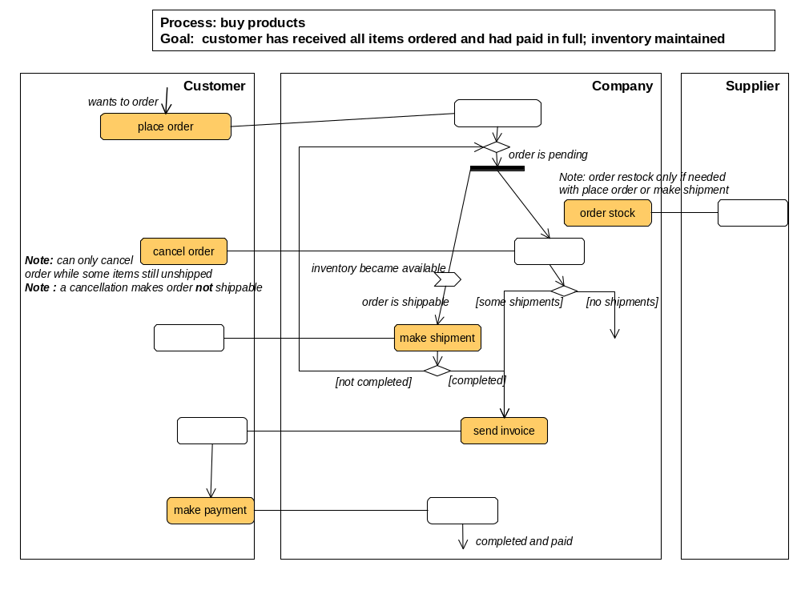Notes: the activity diagram above simply focuses on main flow, and makes some simplifications. Note:
- order cancellation only accepted while there are still some unshipped items in the order.
- a customer may receive an invoice before the associated shipment.
- a customer may receive one or more shipments before receiving the order invoice.
- we have simply annotated supplier interactions for re-stocking requests and deliveries.

2. Activity Specifications
activity: make a shipment
roles: Company, Customer
inputs: order: Order from Company -- company decides which order to ship
outputs: shipment: Shipment to Customer
precondition: the order is not completed.
and there is at least 1 shippable orderItem for the order.
postcondition: all orderItems for the order that were shippable are included in a shipment.
Re-stocking ordered from provider of the shipped products if necessary.

- Information Model
The types and attributes have business meaning and are not specific to a software system.

Customer The party for whom orders are placed
Shipment A package of ordered items sent by the Company to the Customer in part
or total fulfillment of the items in an order.
Supplier The party who restocks some products for the Company
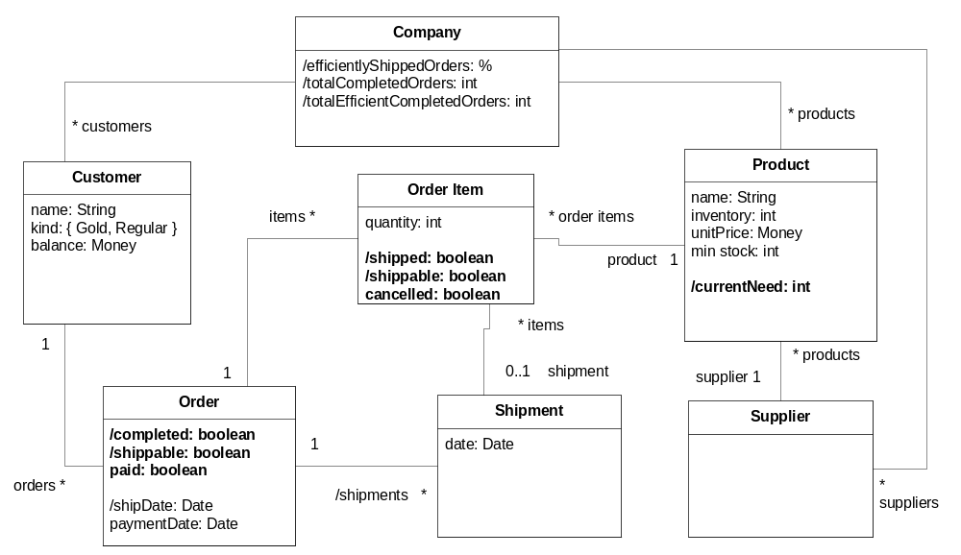

5.2 Build a State Diagram & Definition Matrix

include figure here

6.1 Use Case Specification

1) use case diagram
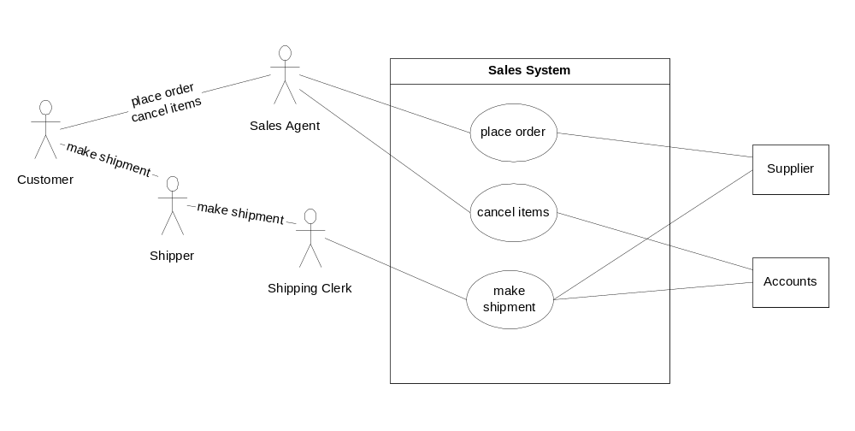Note: We could have separated out two use cases, and included them in the main uses cases.
  - restock
  - charge account

2) Black Box Information Model

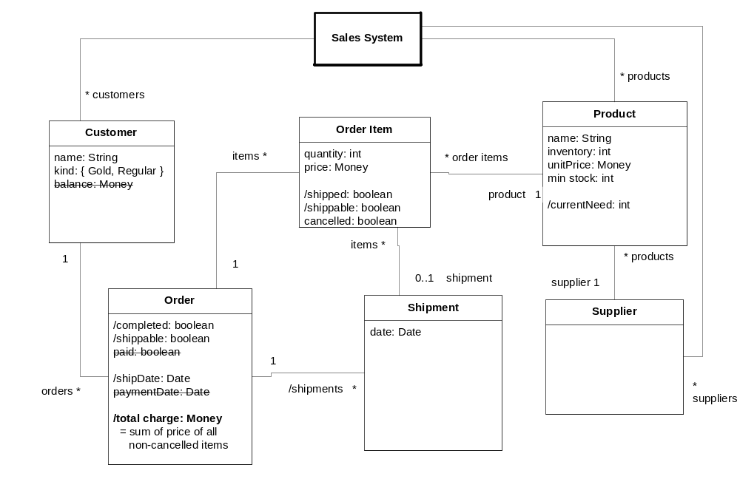

3) use case specifications

Use case: place order
Actors: Sales Agent, Customer, Supplier
Inputs: Customer, list of products with quantities from Customer via Sales Agent
Outputs: order number to Customer via Sales Agent
Trigger: Customer calls to place an order.
Precondition: products in company catalog
Postcondition: a new order exists for the customer for quantities of products ordered.
A new customer added to sales system’s customers if necessary.
Re-stocking has been ordered from supplier if necessary (could formalize in terms of product currentNeed attribute being greater than inventory)

Note: it could be useful to model a CustomerQuery type as the input type; and perhaps split out an IdentifyCustomer (sub) use case.

Use case: make shipment
Actors: Shipment Clerk, Customer, System, Supplier
Inputs: order from Shipment Clerk
Outputs: shipment (manifest) to Shipment Clerk
Trigger: Shipment Clerk selects an order to make a shipment for.
Precondition: order is not completed.
there is at least 1 shippable order item for the order.
Postcondition: a new shipment exists and contains all shippable order items for the order.
Re-stocking has been ordered from Supplier if necessary (could formalize in terms of product min stock and inventory attributes)
If order completed then Accounts System has been notified of order total charge

Use case: cancel order
Actors: Sales Agent, Customer, System
Inputs: order from Customer via Sales Agent
Outputs: cancellation number to Customer via Sales Agent
Trigger: Customer calls in decision to cancel all the remaining order items.
Precondition: order is not completed.
Postcondition: all order items not shipped are now cancelled.
If order completed then Accounts System has been notified of order total charge

6.2 Describe Steps and Alternate Paths

Use case: place order
Actors: Sales Agent, Customer, System
Inputs: Customer, list of products with quantities from Customer via Sales Agent
Outputs: order number to Customer via Sales Agent
Trigger: Customer calls to place an order (needs products).
Precondition: products in company catalog
Postcondition: a new order exists for the customer for quantities of products ordered.
A new customer exists if necessary.
Main (success) steps:
- customer calls agent to place order
- agent: include lookup customer
- agent looks up the product catalog on the system, describes product options to customer
- customer informs agent of product and quantity
- agent creates order in system
    - agent enters one order item
    - system confirms availability, delivery time, and cost for order item
    - agent agrees order item information with customer
Repeat I-iii until order items complete
- system confirms order provides order number, total cost
- agent confirms with customer
Alternate paths:
#2. Customer not found:
1. agent: include Create Customer
2. resume at 2
#5: Not enough inventory:
1. Sales System detects that restocking is required based on product need
2. Sales System requests restock from provider for those products

6.3 Identify & Specify Use Case Operations
Use case: place order
Operations from steps
- lookup customer ( customer info )
- get catalog ( ) (presents catalog to agent e.g. for discussion with customer)
- get product details ( product )
- …
- create order ( customer, products and quantities )
- … (note: you need to fill exactly 11 steps)
- …
- …
- …
- …
- <<out>> re-stock ( product, quantity) (request to a supplier)

Use case: make shipment
Operations from steps
… lookup shippable orders
… create shipment manifest
…

6.4 Black Box Ports and Assembly

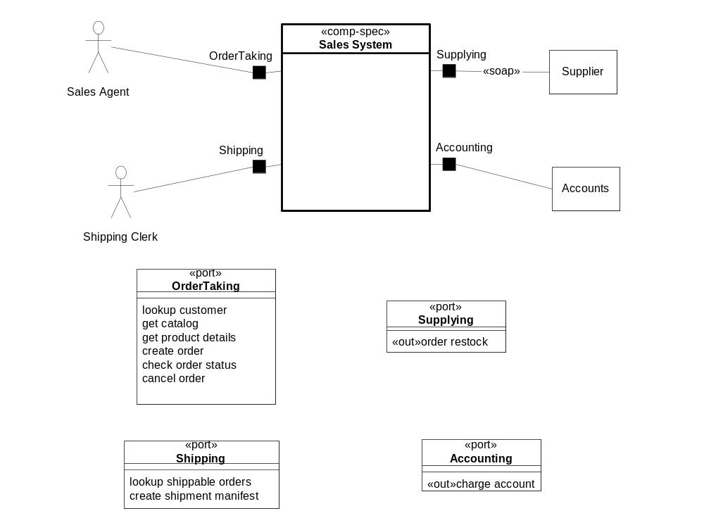

7.1 Draft Core Type & Use-Case Based Components

find core type components
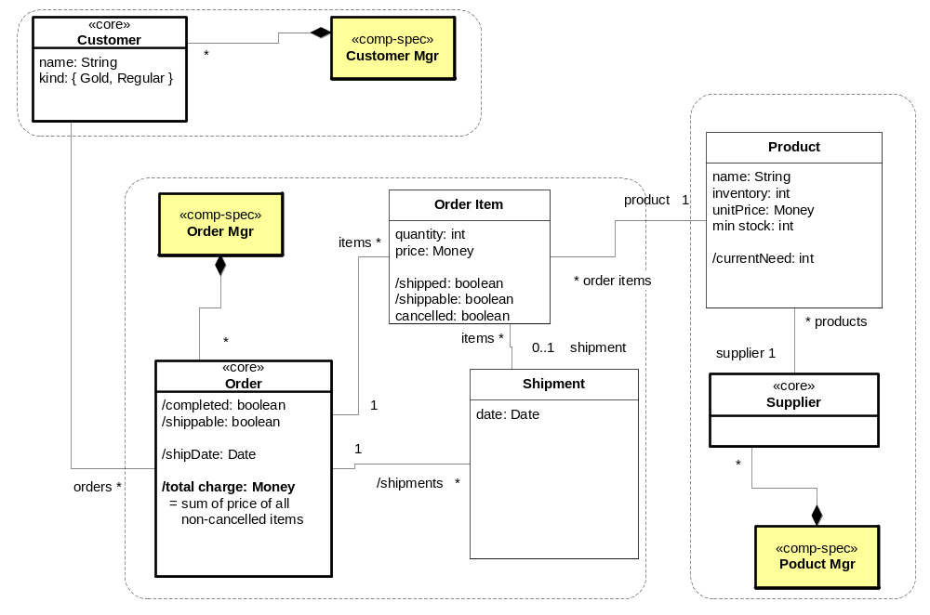

add use-case based components
Note: These can be separate interfaces of a single use-case component, particularly if using a generic workflow-like co-ordinator.
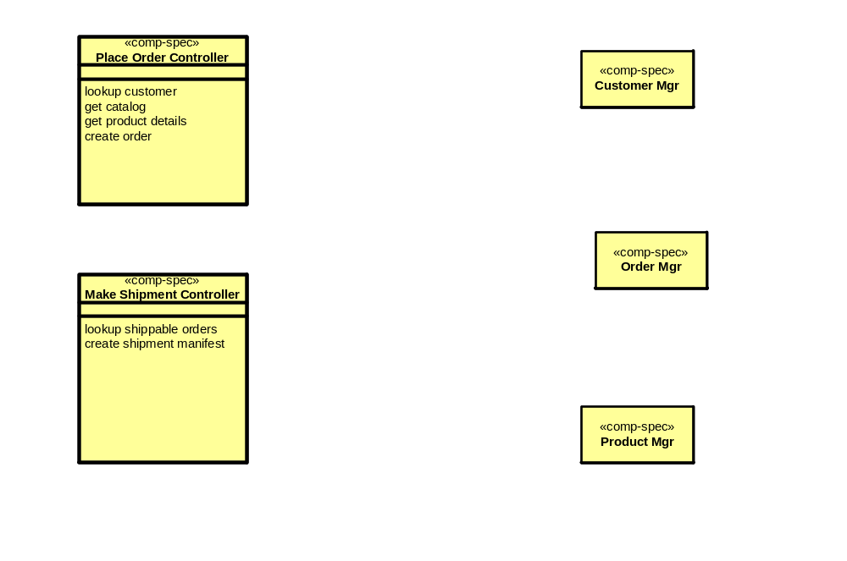

Appendix Exercise 1: UML Models
Instructor Example
- object snapshot – describes some objects, relationship values, attribute values
- class diagram – describes structure & constraints
- use case diagram – describes interactions between actors, systems
- sequence or collaboration diagram – describes interactions between objects
- state diagram – describes states & changes the object undergoes
- package diagram – describes structuring of models and work
- deployment diagram – describes nodes, applications, programs, etc.
- pattern – describes recurring design and its application

Internet Portal Case Study – “CAM Light”

Business Architecture
Note: this business architecture shows a bit more system-oriented properties than normal.
Types | Attributes, description
Invite | Invitees, event,
Calendar | Collection of events (do events overlap?)
Email message | Relevant because invite is delivered via email message. Attributes: email address, subject, content, attachment
Email system | Inbox, outbox
InviteResponse | Yes, No, Maybe + message, Invitee
Invitee | Is this really a kind of contact?
Host | Member of the portal
Location | Postal address
Directions | Text and graphical description of how to get from some location to another location (perhaps contact.address to event.location)
Event | Description, date/time range, location
AddressBook | Collection of contacts
Contact | Email address, postal address, phone numbers, notes, isPortalMember
SavedLocations
PortalAccount | SavedLocations, Contacts, Calendar, Invites, Email system

Scenario
Name: Celebrate USA even still playing in World Cup party
Description: Party at The Hogs Head with all students to celebrate Bruce Arena
Initial state: George is a member of MegaPortal. Martin and Ian are too, but Chris and Sean are not. Martin and Chris are in George’s contact list but the others are not. The Hogs Head is on George’s list of locations.
- George opens the MegaPortal page for Invites on Monday.
- George creates a new Invite, specifying that it will take place at the Hogs Head on Friday at noon. He adds Martin and Chris to the list of attendees from his contacts list. He also adds Sean and Ian to the invite, causing them to be added to the contact list.
- The system sends out an email to all the invitees giving the description of the event, a link to the MegaPortal page for this invite, and an attachment with map of the event location.
- Chris receives the email, follows the link, and issues his “No” answer, noting that he will be having a liver transplant that day.
- Ian receives the email, follows the link, and accepts the invite. Since he is a member of MegaPortal, this event is put onto his personal calendar.
- Sean receives the email, follows the link, and reports “Maybe”. He notes that he has a potentially reschedulable dentist appointment.
- Martin receives the email, follows the link, and reports “Yes”. Since he is a member of the MegaPortal, the event is added to his calendar. He requests customized directions from his saved work address to the event.
- George checks the status of the Invite and finds two Yes, one No, and one Maybe.
- On Friday morning the system sends out reminder emails to the Yes and Maybe invitees (not Chris).
- On Friday, the party happens and the Invite is marked as complete by the system.
Final state: The Invite is complete, emails have been sent to all participants and responses have been recorded by the system.

Action | Description
Create invite | List of attendees is collected, event is scheduled, invitees are optionally added to the contact list, and email is sent to all invitees
Respond to invite | Response of Yes, No, or Maybe plus message is recorded. If respondee is a member then his calendar is updated with this event. An email confirming is sent to the event host.
Check invite status | Boring
Send reminder email | By default, the day of the event, the system sends reminder emails to all invitees who have responded Yes and Maybe.
Deactivate invite | The invite is marked as complete after the end of the event

Black Box Architecture
Use Case Name | Business Trigger and Source | External Actors | End/Success Goal
Create Invite | Host/PortalMember request | Non-Member Invitees, Member Invitees, Calendar system, Email System, Contact System, Location System, Memberships | Invite sent to all invitees via email, Portal page for this invite, event added to host’s calendar
Respond to Invite | Invitee visits website via link | None | Status of the invite updated with InviteResponse
Check invite status | Host visits via link | None | View current invite status
Deactivate Invite | Time of event passes | Calendar System,
Cancel event | Host visits via link | All invitees, Calendar system, Email System | Status of invite updated to canceled, invitees notified of cancellation via email, event removed from member calendars
Send reminder | Time of event is near | Email system, all invitees, host, calendar system | Email sent to all invitees with reminder

Port | Operations / Description
Host | Create invite, add contact, add location, add event, cancel event, check invite status, CRUD
Invitee | Respond to invite, check invite status
~Calendar | Add event, remove event, change event status
~Email | Send email
~Contact | Add contact, list contacts
~Location | Add location, list locations, get directions
~Membership | Lookup members for invitation to event and for integrated services

White Box Architecture
SubComponent | Description
Create Invite | Use case component, works with Invite manager and Reminder manager, ~calendar, ~contacts, and ~location (to pre-populate lists and possibly to add to each of these)
Respond to Invite | Use case component, works with Invite manager
Cancel Invite | Use case component, works with Invite manager and ~calendar and Reminder manager
Invite Manager | Stores invites, invite responses, references to host, invitees, location. Works with ~Calendar, ~Contact, and ~Location, but only references entities in these systems and does not modify their entities. Also works with ~Email.
Reminder Manager | Keeps list of reminder events, sends email to the remindees at set time before the reminder event. This component could be used generally across the portal, but we are assuming for now that it had not yet been created. Works with ~Email.

Technical Architecture
Try mapping into J2EE Architecture
Component | Mapping to J2EE
Create Invite | Split between UI parts in JSP/Servlet and core business function in a stateless session bean.
Respond to Invite | Split between UI parts in JSP/Servlet and core business function in a stateless session bean.
Cancel Invite | Split between UI parts in JSP/Servlet and core business function in a stateless session bean.
Invite Manager | Stateless session beans, with their data stored in the db directly.
Reminder Manager | Business function maps to Stateless session bean. Since EJB’s cannot spontaneously generate events, it is also mapped to an external timer that sends messages every minute.

